REWINDING THE DLR-5
To
HIBAPHONE
(High-Impedance-Balanced-Armature Phone)

By Dejan Momirov

This is a description of the procedure I performed trying to make a high-impedance-high-sensitivity earphone set. The idea was to combine the advantages of high impedance vintage phones with the high sensitivity of an balanced-armature construction. I was more than satisfied with the results and I would like to share my experience with other DX enthusiasts.

I’ve got several DLR-5 earphones and I decided to rewind the spools of one pair.
First I tested their characteristics and here they are (per one element):

- DC-resistance..............................27 Ohms
- AC-impedance at 1 kHz............280 Ohms
- Sensitivity at 1 kHz..................0.13 picoW

It wasn’t easy at all, but I am sure, with the patience and enthusiasm you can also do this.

Before you start, keep in mind:

Don’t rush, take your time!

Don’t panic if something goes wrong! Almost everything is reparable (see also the section troubleshooting).

Keep dust and small particles away.

Control every step as it is done

Never solder or de-solder the coil contacts with the permanent magnet in place because of the strong alternating magnetic field of the soldering iron.

Use magnifying goggles.

Part 1 – Disassembling The Element

At fig.1 you can see the front and rear of the original DLR-5 earpiece, in- and outside the housing.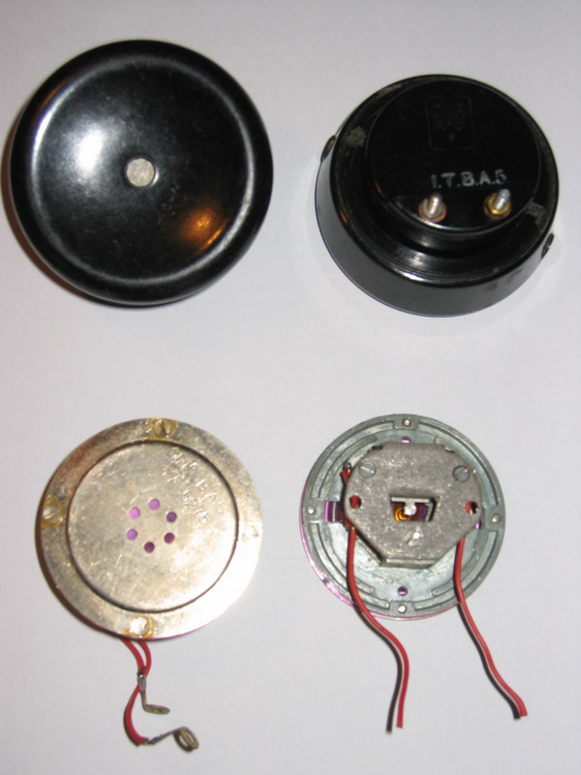

When taking the element out, you should better unscrew the contact screws than desolder the leads in such a small space and near the magnet.
After loosen the three screws on the top, first remove the magnet and then the upper plate of the magnet unit. It is very difficult to work within the strong magnetic field and there is the risk of damaging the armature.
Pull the leads out of the eyelet of the lead holder. Do not desolder the leads from the coil yet! The ends are wound around the coil contact plate.
Unscrew the tiny nut from the drive rod using fine but strong forceps like those shown at
Fig. 2. (Bent microsurgical or the depilation forceps).

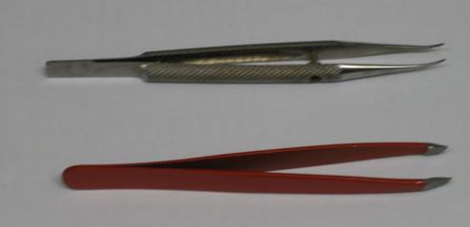

Remove the coil, with the armature still inside straight upwards, to avoid damaging the drive rod.
Bottom plate of the magnet unit has to be removed only if you should clean it from the hardened varnish. It is important to clean it because the varnish can later interfere with the reassembling the coil, damaging the wire, or can break and the particles can fall into the diaphragm space or between the armature and the coil.
The diaphragm, drive rod and the second nut you should leave in place. Try not to touch the lower nut, because it determines the central position of the armature.

All parts are shown at the fig. 3.

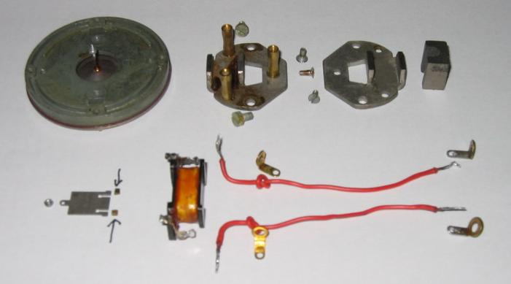

Important: the two tiny ”U”-shaped parts, marked with the arrows at the photograph (fig 3), are the only two fixation points of the armature, and they also determine the distance between back end of the armature and the poles of the magnet unit. Remember the position of the two pieces before removing the armature from the coil form and don’t loos them!

Part 2 –Preparing The Coil Form

At the coil form, you see two contact-plates with lead contact and coil-wire contact each.
Using two pairs of tong, as shown at fig. 4, bend them straight or a few degrees further. Don’t hold the coil; the form can break by bending!

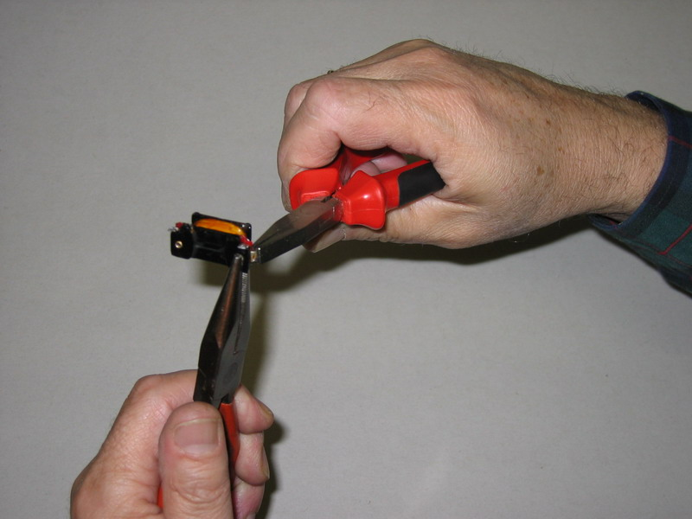

Now remove the original wire. (You can keep it, just in case you decide to undo the whole job!) ) and clean the coil form from the varnish. Also clean the soldering points.
Remove the isolation from the contact plates and polish them as well as the edges of the form with the fine sand-paper (# 360 or higher). The whole inner side should be smooth and without any obstacles, otherwise it could catch and break the delicate wire later.
Fig.5 shows the form ready for winding.

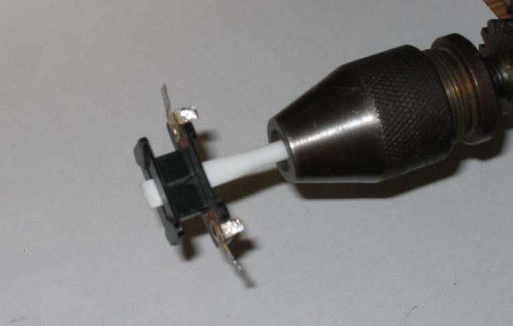

Part 3 – The Wire

The idea of the whole project was to get higher impedance and that means as much turns as possible. To achieve that, you need the thinnest wire you can get and maximum space for it.
The wire I used was enamel coated 0.05 mm from a reed-relay activating coil. Another way is to order it via Internet. I ordered some by CONRAD (www.conrad.nl), order nr. 60 75 09-06, cost 3.55 Euro +p.p. One spool (cc 1500 m) is enough for pair of phones. Anyway, the wire must be solderable. The wires I use are shown at fig. 6. Available space is limited by the mounting rods, as shown at fig. 7. You can not stuff the whole form because of the clearance of 18 mm between the two mounting rods. The drawing also shows how you have to bend the contacts from their original position (marked 1.) to the temporary winding position (marked 2.). After winding, bend them back to the position 1. See also fig. 4! Mark 3. is available wire-space.

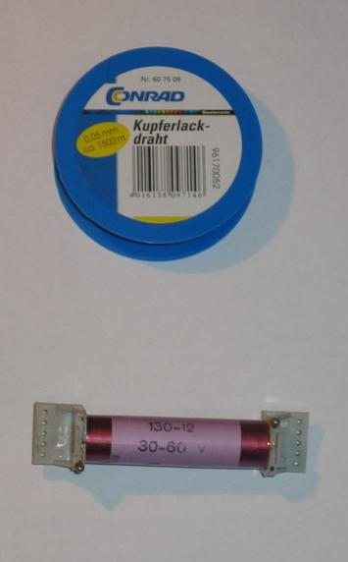 ← Fig. 6

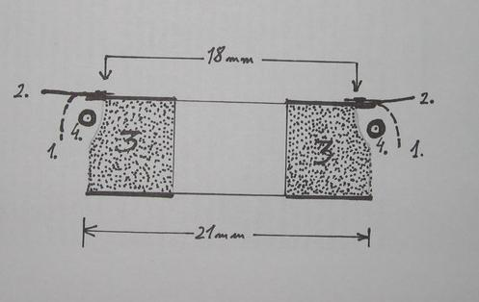 ← Fig. 7

Part 4 – Winding

When everything is ready, begins the real work and excitement!
I have recently got a winding device for old 8mm films, shown at fig. 8.

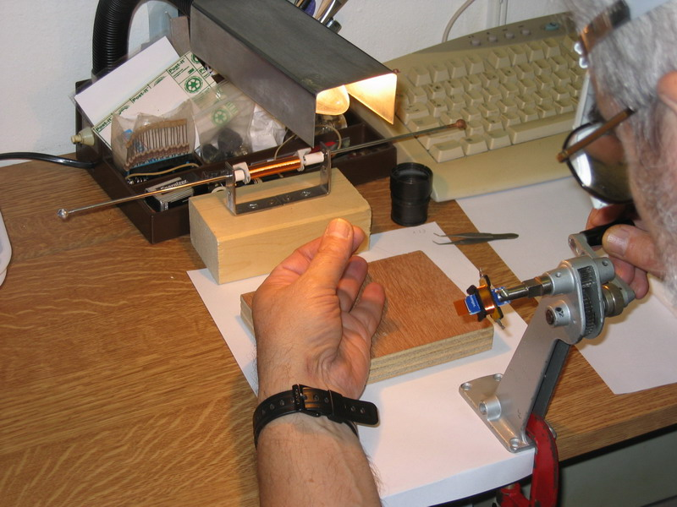

You can also use a hand-drill fixed in the claws, as I did for years (fig. 9).

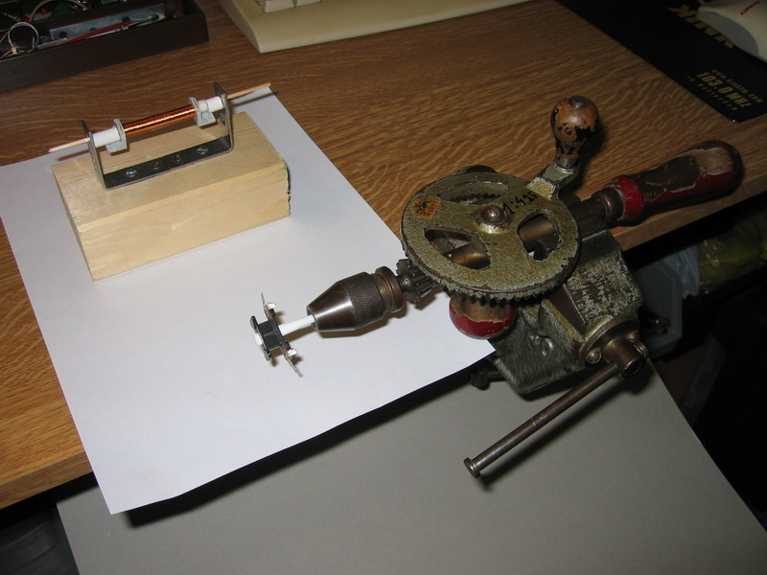

It is very important to centre the form perfectly, otherwise the windings can escape over the form edge.

Besides wearing magnifying goggles, do have a bright spot light and put a white paper under the coil and the wire. It is important to see the wire and how you feed it. You can see better by looking with only one eye! Choose the direction of winding so that the wire comes from upside the coil. The source-spool must also spin easily, without any resistance. With your left hand, rested on the confortable height, you lead the wire, organise it within the coil, and keep it under a slight tension. See fig 8. Try to organise the windings as good as possible, don’t make criss-cross, it takes unnecessary space. Try first a few layers to get some experience and to feel the maximal tension before breaking the wire.

Than cut a few small strips of adhesive tape. You shall need them to fix the wire at the coil if you have to make a break for any reason.

Secure the start by making a threefold loop of 4-5 cm and twist it. Bend it around the soldering contact (do not cut it!) and make the first few turns with such a strengthened twisted part and then continue with single wire layers. Do the same with the end!

Mark at the paper every 100 turns if you do not have automatic counter. You will later want to know how many turns you have put into the coil. You can calculate the total number of wire turns by multiplying the number of drill-handle turns with the turn-ratio.
After finishing the winding, solder the ends and protect the windings with a 7mm wide strip of thin elastic adhesive tape, or a thin layer of a transparent nail-polish.

Control the clearance for the two mounting rods, it should be 18 mm. Also control with the Ohm-meter if the contacts are good. The DC resistance should be between 1500 to 2000 Ohms.

Part 5 – Reassembling The Element

Clean and check all parts prior to reassemble the unit in opposite sequence. That means the bottom plate first. Slide the armature in the coil with small hole facing the contact-side. Than put the coil (with the armature inside and the two small fixation “U”-shaped parts in place), vertically into the bottom plate so that the poles fit into the special grooves on the coil form. The drive rod must pass through the small hole of the armature, and two fixation pieces must lay at the pole of the magnet unit bottom plate.
Now put back the upper nut of the drive rod and fasten the armature.
It is of crucial importance to check if the armature is free and at equal distance on both sides within the central slit of the coil form!!! If not – adjust with both nuts and tighten it. Remember that the vibrations of the armature have to be transferred to the drive rod and finally to the diaphragm. When you put back the upper plate, adjustment would be very difficult, if not impossible.
When everything is OK, put back the upper plate so that the poles fit into the upper grooves of the coil form. Put the screws back, but don’t fasten them yet. First slide the magnet back and than fasten the screws.
Pull the leads through the eyelet of the lead-holder and check once again if the armature is at central position. If you look through the coil against the light, you should see equal spacing between the armature and the poles of the magnet unit. Also check if the lead contacts are not touching the adjacent metal parts.
Now put back the contact-screws and fix the element into the housing.
Connect the flexible cable and the head-band and...finally you’ve got it! (Fig 10)

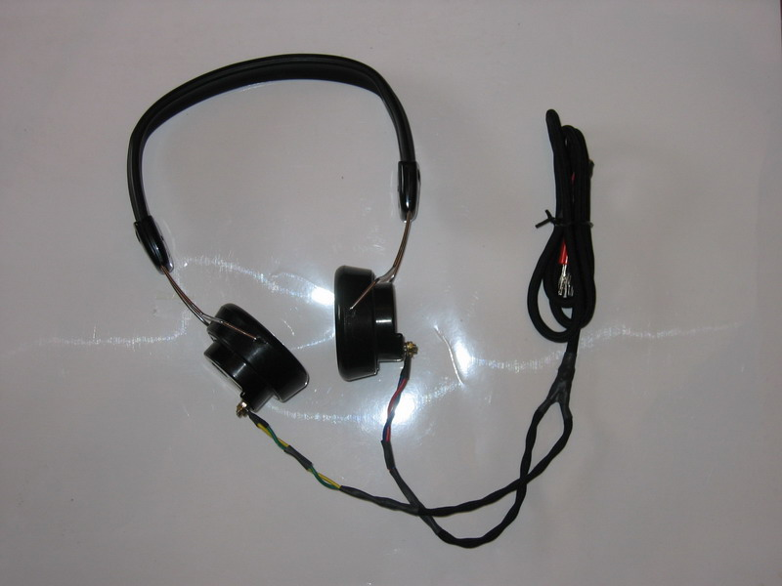

Part 6 – Testing The Phones

To check the presumed characteristics you can test the phones or simply compare with another set you have.

I rewound two elements and tested the headphone-set using the following instruments: PHILIPS LF Generator PM 5100, PHILIPS dual oscilloscope model PM 3207, Digital AVO-meter Conrad Electronics M830B and analogue Velleman Multitester 40000 Ohms/V.
There are many procedures described on the Web to test the AC impedance and the sensitivity. I applied the one described by Dick Kleiert, with a small variation: for R1 I used 50 kOhms instead of 10 kOhms for better reading of the input voltage (200 mV).

Here are the results:
- Windings per element................5300 + 5000
- DC Set resistance...................................3870 Ohms (2050 + 1840 )
- AC Impedance at 1 kHz.......................56000 Ohms (pair)
- Threshold sensitivity at 1 kHz...........0.00028 picoW (pair)

The term “threshold sensitivity” has to describe that I just was able to hear the 1 kHz signal in the compete silence. Of course, to understand the speech or music, you need more input energy.

Part 7 – Troubleshooting

In spite of all the attention and care there is always something what can go wrong. Here are some situations, and how you can manage them:

- One of the two “U”- shaped armature-fixation parts jumps off and you can not find it any more.
* Take a 0.2 mm thin sheet of a non-magnetic metal and cut a strip 2mm wide and 5 mm long. Bend it around 0.6 mm, (that is the thickness of the armature) in a U-shape.

- Coil form brakes.
* Cut a piece 3 x 8 mm of thin (0.15-0.2 mm) pertinaks or similar hard non- metallic material and glue the patch from inside (wire-side) with cyanacryl glue.

- The wire breaks.
* Fix the last layer at the coil with the piece of adhesive tape and twist both broken wire-ends together. Solder the joint, cut it off to the length of about 2 mm and continue winding. It’s no need of any isolation (occupies the precious space), just cover it with the next layer of wire.

- You loos the tiny nut of the drive rod.
* Try to get one by the watch-maker or by an optician, or in some hobby-shop. Take the element with you to check the size.

Maybe it is a good idea to have one extra (third) phone-element, just for the spare parts or to try again by serious problems.

Part 8 – Epilogue

I am aware of the fact that my effort and the result is not enough for a serious DX-work, but it is fun to try something new. Maybe I made some mistakes, in approach or by the testing. If anyone does or has done something similar, I would be grateful for any comments, corrections or confirmations. Also if you want some more information, mail me at d.mom@planet.nl

And finally, fig. 11 shows my hobby-corner where everything has been done.

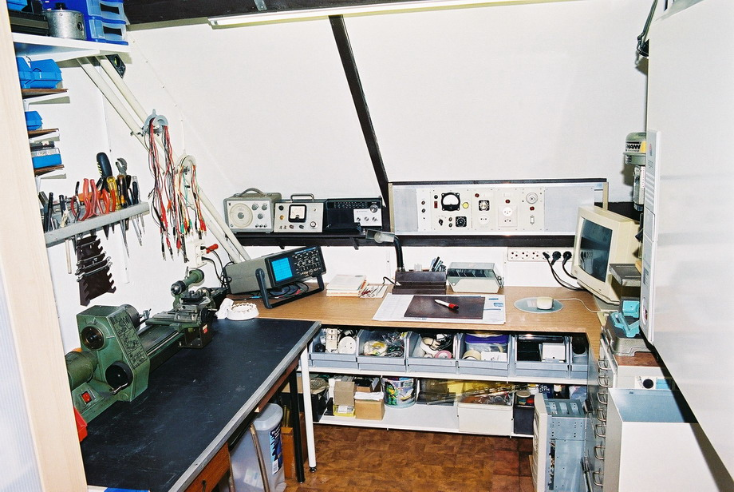

Good luck,
Dejan

Rotterdam, October 2005

